# Studio Akef

## Definition

**# Source**: **Chatgpt (GPT-5-Standard) at [8/27/2025]**

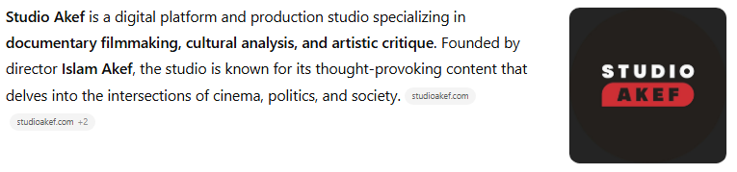

**Studio Akef** is a digital platform and production studio specializing in **documentary filmmaking, cultural analysis, and artistic critique**. Founded by director **Islam Akef**, the studio is known for its thought-provoking content that delves into the intersections of cinema, politics, and society.([studioakef.com](https://www.studioakef.com/korea-militarism?utm_source=chatgpt.com), [studioakef.com](https://www.studioakef.com/azioniststory?utm_source=chatgpt.com))

## Studio Akef Overview

**# Source**: **Chatgpt (GPT-5-Standard) at [8/27/2025]**

* **Name**: Studio Akef (ستوديو عاكف)
* **Founder**: Islam Akef
* **Language**: Arabic
* **Content Focus**: Documentaries, cultural analysis, and artistic critique
* **Primary Platform**: [studioakef.com](https://www.studioakef.com/)
* **Social Media**: [Instagram](https://www.instagram.com/studioakef/), [Facebook](https://www.facebook.com/studioakef/), [YouTube](https://www.youtube.com/@Studioakef)([Facebook](https://www.facebook.com/studioakef/videos/nobody-free-till-palestine-is-free-amsterdam/1211273186561098/?utm_source=chatgpt.com), [YouTube](https://www.youtube.com/watch?v=zCHl27YLRj8&utm_source=chatgpt.com), [studioakef.com](https://www.studioakef.com/?utm_source=chatgpt.com))

## Content Themes

**# Source**: **Chatgpt (GPT-5-Standard) at [8/27/2025]**

Studio Akef's productions explore a diverse range of topics, including:

* **Cinematic History**: Analyzing the evolution of film industries across different cultures.
* **Political Narratives**: Examining how cinema reflects and influences political ideologies.
* **Cultural Identity**: Investigating the portrayal of cultural identities in media.
* **Artistic Expression**: Critiquing artistic movements and their impact on society.

## Notable Productions

**# Source**: **Chatgpt (GPT-5-Standard) at [8/27/2025]**

* **Sinful Cinema**: A docuseries exploring the history and impact of controversial films.
* **Islam in Amsterdam**: A journey through Amsterdam's alleys to discover the roots and shadows of cinema.
* **Korea & Militarism**: An exploration of South Korean cinema's inception amidst the complex social and political milieu of the 1980s.
* **A Zionist Story**: A cinematic journey through time and space to discover the Israeli interior between the 1967 victory and the 1973 defeat.([studioakef.com](https://www.studioakef.com/islam-in-amsterdam?utm_source=chatgpt.com), [studioakef.com](https://www.studioakef.com/korea-militarism?utm_source=chatgpt.com), [studioakef.com](https://www.studioakef.com/azioniststory?utm_source=chatgpt.com))

**📺 Social Media Presence**

Studio Akef maintains an active presence on various social media platforms, allowing fans to engage with the content and stay updated on new releases:

* **Instagram**: [@studioakef](https://www.instagram.com/studioakef/)
* **Facebook**: [Studio Akef](https://www.facebook.com/studioakef/)
* **YouTube**: [Studio Akef Channel](https://www.youtube.com/@Studioakef)([Instagram](https://www.instagram.com/studioakef/?utm_source=chatgpt.com), [YouTube](https://www.youtube.com/%40Studioakef/videos?utm_source=chatgpt.com))

## Summary Table

**# Source**: **Chatgpt (GPT-5-Standard) at [8/27/2025]**

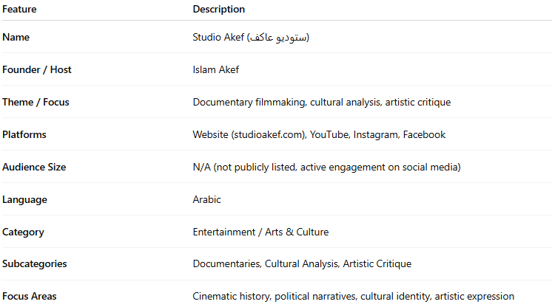

| **Feature** | **Description** |
| --- | --- |
| **Name** | Studio Akef (ستوديو عاكف) |
| **Founder / Host** | Islam Akef |
| **Theme / Focus** | Documentary filmmaking, cultural analysis, artistic critique |
| **Platforms** | Website (studioakef.com), YouTube, Instagram, Facebook |
| **Audience Size** | N/A (not publicly listed, active engagement on social media) |
| **Language** | Arabic |
| **Category** | Entertainment / Arts & Culture |
| **Subcategories** | Documentaries, Cultural Analysis, Artistic Critique |
| **Focus Areas** | Cinematic history, political narratives, cultural identity, artistic expression |